

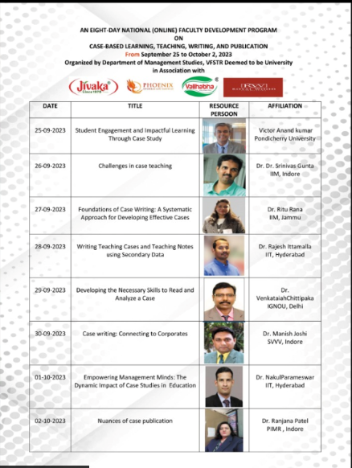

**Note: Session(s) Time – 4.00 PM to 6.00 PM**



**SESSION – I - INSIGHTS**

[Type / Write from here]

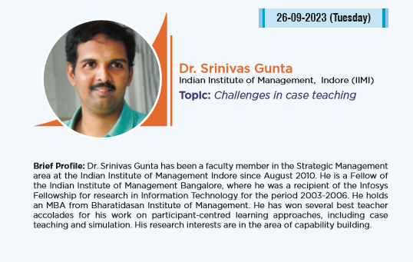

**SESSION – II - INSIGHTS**

[Type / Write from here]



**SESSION – III - INSIGHTS**

[Type / Write from here]



**SESSION – IV - INSIGHTS**

[Type / Write from here]



**SESSION – V - INSIGHTS**

[Type / Write from here]

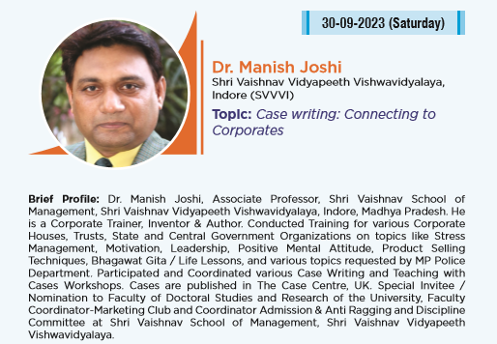

**SESSION – VI – INSIGHTS**

[Type / Write from here]



**SESSION – VII – INSIGHTS**

[Type / Write from here]



**SESSION – VII – INSIGHTS**

[Type / Write from here]



